SPEC No. |  | MULTI-LINK SWITCH PANEL SPECIFICATION
 |  | CUSTOMER:
SWITCH No. | LEGEND | COLOUR | BUILD NOTES
SW1
SW2
SW3
SW4
SW5
SW6
SW7
SW8
SW9
SW10
SW11
SW12
SW13
SW14
SW15/
PTT
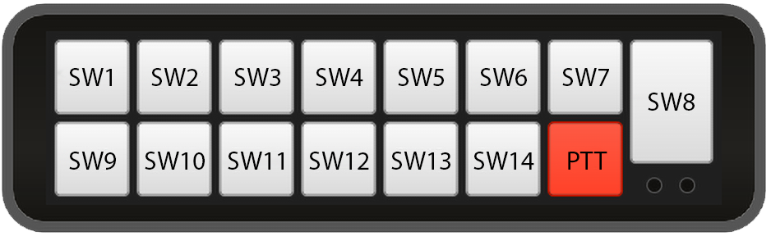
Note: SW15/PTT can be used for any function, but is the only button that can be programmed as ‘Push to Talk’.

MOUNTING ORIENTATION (PLEASE TICK BOX) 

